Web.xml – Deployment Descriptor (All the info related to deployment)

Deployment – it is a process of loading the code in the server

Web Application –

Application packaging – jar, war

JAR – Java Archieve

WAR – Web Archieve

Java SE – Java Standard Edition

Java EE – Java Enterprise Edition (SE + Web + JMS + JNDI + Mail + EJB )

Core Java Applications – Java SE applications (Stand-alone Applications) [Download & install]

Web Application – Java EE Application

Web.xml – File (Deployment Descriptor) [Optional when we use Java 5 and above]

Annotations are introduced in Java 5.

<servlet-details>

<servlet-mapping>

<welcome-file>

Index.jsp

Index.html

Index.html

Home.html

Home.htm

Home.jsp

XML is both case and space sensitive.

Modifying xml file will restart the server and re-deploy the application.

Constraints – Conditions

1. Primary Key (Unique + Not null) Each table must have a primary key.
2. Secondary Key / Foreign Key (Optional) – Used to specify the relations between the table (This enforces that valid data is entered in secondary table)
3. Unique (Duplicates not allowed)
4. Not Null (Null value is not allowed – but duplicates allowed)
5. Generated (Data will be automatically generated)
6. Auto Increment [AI] – Sequence will be generated and used for Providing the primary key value (numerical primary key)
7. Zero Filled
8. Unsigned (Only positive numbers allowed – No negative numbers)
9. Check

Composite Primary Key – (Create a primary combining two or more columns)

CRUD Query

Clauses –

WHERE – used to specify some conditions

Group By – used to group based on column

Count – count no of rows/columns

Between – To specify a range

In – to provide valid list of data

Any – to provide & verify the data from given set of data

Order by – to sort based on certain columns

Like – used to search for string match

Types of Query

1. Simple Query
2. Sub Query – Query with in another Query
3. Complex or Join queries – used to connect columns from two or more tables.

Types of Joins

1. Inner Join
2. Outer Join
3. Left Join
4. Right Join
5. Self Join
6. Full Join

<https://www.w3schools.com/sql/sql_join.asp>

Functions – Predefined Functions (Already provided by database creators) – System Defined Functions

* Row level function (UPPER, LOWER,)
* Column level function (MAX(), MIN(), AVG())
* Aggregate Function
* Numerical function
* Date function
* String function

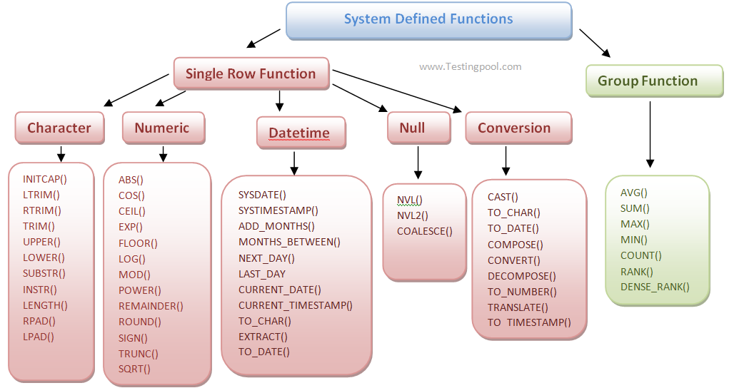

CREATE TABLE `delo`.`course` (

`id` INT NOT NULL AUTO_INCREMENT,

`name` VARCHAR(75) NULL,

`duration` INT NULL,

`description` VARCHAR(255) NULL,

`url` VARCHAR(155) NULL,

PRIMARY KEY (`id`));

INSERT INTO `delo`.`course` (`name`, `duration`, `description`, `url`) VALUES ('JAVA FSD', '80', 'Core Java, Adv Java, Spring, MicroServices, RDBMS', 'http://syskan.com/jfsd');

INSERT INTO `delo`.`course` (`name`, `duration`, `description`, `url`) VALUES ('.Net FSD', '80', '.Net Core, .Net MVC, Angular, RDBMS', 'http://syskan.com/nfsd');

CREATE TABLE `delo`.`course_trainees` (

`id` INT NOT NULL AUTO_INCREMENT,

`course_id` INT NOT NULL,

`trainee_id` INT NOT NULL,

PRIMARY KEY (`id`),

INDEX `c_fkey_idx` (`course_id` ASC) VISIBLE,

INDEX `t_fkey_idx` (`trainee_id` ASC) VISIBLE,

CONSTRAINT `c_fkey`

FOREIGN KEY (`course_id`)

REFERENCES `delo`.`course` (`id`)

ON DELETE NO ACTION

ON UPDATE NO ACTION,

CONSTRAINT `t_fkey`

FOREIGN KEY (`trainee_id`)

REFERENCES `delo`.`trainees` (`id`)

ON DELETE NO ACTION

ON UPDATE NO ACTION);

INSERT INTO `delo`.`course_trainees` (`course_id`, `trainee_id`) VALUES ('1', '1');

INSERT INTO `delo`.`course_trainees` (`course_id`, `trainee_id`) VALUES ('1', '2');